# HEMVATI NANDAN BAHUGUNA GRAHWAL UNIVERSITY

# (A CENTRAL UNIVERSITY) SRINAGAR GARHWAL UTRRAKHAND

**Project Report on**

# “WEBSITE BASED ON UTTRAKHAND”

**Submitted For Partial Fulfilment Of**

**Master in Computer Application H.N.B Garhwal University (A Central University) Srinagar garhwal.**

**2020-2022.**



**SUBMITTED BY: - SUBMITTED TO:-**

**RACHIT PANWAR DR. OM PRAKASH**

**MCA 4TH SEM ASSISTANT PROFESSOR**

**ENROLMENT NO:-G172200102 CSE DEPARTMENT**

# Hemvati Nandan Bahuguna Garhwal University

# CERTIFICATE

**This is to certify that project entitled “website based on utrrakhand” submitted by Rachit panwar in the partial fulfilment of the requirement for the award of the degree “MASTER IN COMPUTER APPLICATION” is**

**a record of bonafied work carried out in this organisation under my supervision has not been submitted anywhere else for any other purpose.**

**Prof. Y P Raiwani**

**(HOD & DEAN SOET)**

# ACKNOWLEDGEMENT

# I am grateful to my college “HEMVATI NANDAN BAHUGUNA GRAHWAL UNIVERSITY(A CENTRAL UNIVERSITY) SRINAGAR GARHWAL UTRRAKHAND” and my HOD Prof.Y P raiwani for giving me an opportunity to undergo training program which is a part of course curriculum in MCA[MASTER IN COMPUTER APPLICATION].i have prepared the project entitled “WEBSITE BASED ON UTTRAKHAND”.

**I am grateful to my faculty for giving me the correct guidance. Under her supervision I am able to complete this project successfully.**

**MR. RACHIT PANWAR MCA 4TH SEM**

# DECLARATION

**I hereby declare that project report entitled “WEBSITE BASED ON UTTRAKHAND” has been written and submitted by me under guidance of computer science faculty in my original work.**

**The finding in the report is based on the task done by me in”HEMVATI NANDAN BAHUGUNA GARHWAL UNIVERSITY”. While preparing the report, I have not copied anything from any source or other project submitted for the similar purpose.**

**Place: SRINAGAR GARHWAL RACHIT PANWAR**

**DATE:**

# CONTENTS

1. **Introduction :-**

**About PROJECT TOPIC**

* + **Objective**

1. **System study :-**

**System objective**

* + **Feasibility study**

1. **System analysis**
   * **Software and hardware requirement specification**
2. **System design**
   * **Data flow diagram**
   * **Entity relationship diagram.**
   * **Database design**
3. **Input output screenshots**
4. **Testing**
5. **Maintenance**
6. **Conclusion**
7. **Future scope**
8. **References**

**INTRODUCTION**

# INTRODUCTION

**Uttarakhand, formerly Uttaranchal, state of**[**India**](https://www.britannica.com/place/India)**, located in the northwestern part of the country. It is bordered to the northwest by the Indian state of**[**Himachal Pradesh**](https://www.britannica.com/place/Himachal-Pradesh)**, to the northeast by the**[**Tibet**](https://www.britannica.com/place/Tibet)[**Autonomous**](https://www.merriam-webster.com/dictionary/Autonomous)**Region of**[**China**](https://www.britannica.com/place/China)**, to the southeast by**[**Nepal**](https://www.britannica.com/place/Nepal)**, and to the south and southwest by the Indian state of**[**Uttar Pradesh**](https://www.britannica.com/place/Uttar-Pradesh)**. Its capital is the northwestern city of**[**Dehra Dun**](https://www.britannica.com/place/Dehra-Dun)**.**

**On November 9, 2000, the state of Uttaranchal—the 27th state of India—was carved out of Uttar Pradesh, and in January 2007 the new state changed its name to Uttarakhand, meaning “northern region,” which was the traditional name for the area. Area 19,739 square miles (51,125 square km). Pop. (2011) 10,116,752.**

## Land

## Relief

**Uttarakhand has a highly varied topography, with snow-covered peaks, glaciers, deep canyons, roaring streams, beautiful lakes, and a few patches of dusty plains in the south. Some of the highest mountains in the world are found in Uttarakhand. Most notably, these include Nanda Devi (25,646 feet [7,817 metres]), which is the second highest peak in India, Kamet (25,446 feet [7,756 metres]), and Badrinath (23,420 feet [7,138 metres]).**

**Uttarakhand can be divided into several physiographic zones, all running parallel to each other from northwest to southeast. The northern zone, popularly known as the Himadri, contains segments of the Zaskar and the Great Himalaya ranges, with elevations ranging roughly from 10,000 to 25,000 feet (3,000 to 7,600 metres). Most of the major peaks are located in this zone. Adjacent to and south of the**[**Great Himalayas**](https://www.britannica.com/place/Great-Himalayas)**is a zone containing the**[**Lesser Himalayas**](https://www.britannica.com/place/Lesser-Himalayas)**, known popularly as the Himachal, with elevations between about 6,500 and 10,000 feet (2,000 to 3,000 metres); the zone has two linear ranges—the [Mussoorie](https://www.britannica.com/place/Mussoorie) and the Nag Tibba. To the south of the Himachal is a stretch of the**[**Siwalik Range**](https://www.britannica.com/place/Siwalik-Range)**. The entire area containing the Himadri, the Himachal, and the Siwaliks is broadly known as the [Kumaun Himalayas](https://www.britannica.com/place/Kumaun-Himalayas). The southern edge of the Siwalik Range merges with a narrow bed of gravel and alluvium known as the Bhabar, which interfaces to the southeast with the marshy terrain known as the [Tarai](https://www.britannica.com/place/Tarai). The combined Siwalik-Bhabar-Tarai area ranges in elevation from 1,000 to 10,000 feet (300 to 3,000 metres). South of the Siwaliks are found flat-floored depressions, known locally as duns, such as the**[**Dehra Dun**](https://www.britannica.com/place/Dehra-Dun)**.**

## Drainage

**The state is drained by various rivers of the**[**Ganges**](https://www.britannica.com/place/Ganges-River)**(Ganga) system. The westernmost watershed is formed by the**[**Yamuna River**](https://www.britannica.com/place/Yamuna-River)**and its major tributary, the Tons. The land to the east of this basin is drained by the**[**Bhagirathi**](https://www.britannica.com/place/Bhagirathi-River)**and the Alaknanda—which join to form the Ganges at the town of Devaprayag—and the Mandakini, Pindar, and Dhauliganga, all principal tributaries of the Alaknanda. To the east again are the southward-flowing Ramganga and [Kosi](https://www.britannica.com/place/Kosi-River) rivers, and draining to the southeast in the same region are the Sarju and Goriganga, both of which join the Kali at Uttarakhand’s eastern border with**[**Nepal**](https://www.britannica.com/place/Nepal)**.**

## Soils

**Uttarakhand has various types of soil, all of which are**[**susceptible**](https://www.britannica.com/dictionary/susceptible)**to soil erosion. In the north, the soil ranges from gravel (debris from glaciers) to stiff clay. Brown**[**forest**](https://www.britannica.com/science/forest)**soil—often shallow, gravelly, and rich in organic content—is found farther to the south. The Bhabar area is characterized by soils that are coarse-textured, sandy to gravelly, highly porous, and largely infertile. In the extreme southeastern part of the state, the Tarai soils are mostly rich, clayey loams, mixed to varying degrees with fine sand and humus; they are well suited to the cultivation of rice and sugarcane.**

## Climate

**The climate of Uttarakhand is temperate, marked by seasonal variations in temperature but also affected by tropical**[**monsoons**](https://www.britannica.com/science/monsoon)**. January is the coldest month, with daily high temperatures averaging below freezing in the north and near 70 °F (21 °C) in the southeast. In the north, July is the hottest month, with temperatures typically rising from the mid-40s F (about 7 °C) to about 70 °F daily. In the southeast, May is the warmest month, with daily temperatures normally reaching the low 100s F (about 38 °C) from a low around 80 °F (27 °C). Most of the state’s roughly 60 inches (1,500 mm) of annual precipitation is brought by the southwest monsoon, which blows from July through September. Floods and landslides are problems during the rainy season in the lower stretches of the valleys. In the northern parts of the state, 10 to 15 feet (3 to 5 metres) of snowfall is common between December and March.**

## Plant and animal life

**Four major forest types are found in the Uttarakhand, including alpine meadows in the extreme north,**[**temperate forests**](https://www.britannica.com/science/temperate-forest)**in the Great Himalayas, tropical**[**deciduous forests**](https://www.britannica.com/science/deciduous-forest)**in the Lesser Himalayas, and**[**thorn forests**](https://www.britannica.com/science/thorn-forest)**in the Siwalik Range and in parts of the Tarai. According to official statistics, more than 60 percent of Uttarakhand is under forest cover; in actuality, however, the coverage is much less. The forests provide not only timber and fuel wood but also**[**extensive**](https://www.britannica.com/dictionary/extensive)**grazing land for livestock. Only a small portion of the state’s total land area has permanent pastures.**

**Common tree species of the temperate forests include Himalayan cedar (Deodar cedar), Himalayan (blue) pine,**[**oak**](https://www.britannica.com/plant/oak)**,**[**silver fir**](https://www.britannica.com/plant/silver-fir)**, spruce, chestnut, elm, poplar, birch, yew, cypress, and rhododendron. Tropical deciduous forests of sal, teak, and shisham—all hardwoods—occur in the submontane tract. Thorn forests of dhak (a type of flowering tree), babul (a type of acacia), and various bushes occur in the south.**

**Uttarakhand has a rich array of animal life. Tigers, leopards, elephants, wild boars, and sloth bears are among the state’s large mammals. Common birds include pigeons, doves, ducks, partridges, peacocks, jays,**[**quail**](https://www.britannica.com/dictionary/quail)**, and woodpeckers. Crocodiles are found in some areas. Lions and rhinoceroses have become extinct in the region. A number of national parks and sanctuaries have been established to preserve Uttarakhand’s wildlife.**

# People of Uttarakhand

## Population composition

**Uttarakhand has a multiethnic population spread across two recognized geocultural regions: the Gahrwal, which corresponds roughly to the northwestern half of the state, and the Kumaun, which spans the southeast. [Rajputs](https://www.britannica.com/topic/Rajput) (various clans of landowning rulers and their descendants)—including members of the**[**indigenous**](https://www.merriam-webster.com/dictionary/indigenous)**Garhwali, Gujjar, and Kumauni**[**communities**](https://www.merriam-webster.com/dictionary/communities)**, as well as a number of immigrant peoples—constitute a large portion of the population. Of the total population, nearly one-fifth belongs to the**[**Scheduled Castes**](https://www.britannica.com/topic/untouchable)**(an official**[**designation**](https://www.merriam-webster.com/dictionary/designation)**for those groups that traditionally have occupied a low position within the Indian**[**caste**](https://www.britannica.com/topic/caste-social-differentiation)**system); these people are collectively called Kols or [Doms](https://www.britannica.com/topic/Dom-caste). Scheduled Tribes (an official category embracing indigenous peoples who fall outside the Indian social system), such as the Raji, who live near the border with**[**Nepal**](https://www.britannica.com/place/Nepal)**, account for less than 5 percent of the population.**

**Most of the people of Uttarakhand speak**[**Indo-Aryan languages**](https://www.britannica.com/topic/Indo-Aryan-languages)**.**[**Hindi**](https://www.britannica.com/topic/Hindi-language)**is the official language of the state.**[**Hindustani**](https://www.britannica.com/topic/Hindustani-language)**, which contains words from both Hindi and**[**Urdu**](https://www.britannica.com/topic/Urdu-language)**, is the principal**[**spoken language**](https://www.britannica.com/topic/speech-language)**. Other languages used in Uttarakhand include Garhwali and Kumauni (both [Pahari languages](https://www.britannica.com/topic/Pahari-languages)),**[**Punjabi**](https://www.britannica.com/topic/Punjabi-language)**, and**[**Nepali**](https://www.britannica.com/topic/Nepali-language)**.**

**More than four-fifths of Uttarakhand’s residents are**[**Hindu**](https://www.britannica.com/topic/Hinduism)**.**[**Muslims**](https://www.britannica.com/topic/Islam)[**constitute**](https://www.merriam-webster.com/dictionary/constitute)**the largest religious minority, accounting for about one-tenth of the population. Smaller communities of**[**Sikhs**](https://www.britannica.com/topic/Sikhism)**,**[**Christians**](https://www.britannica.com/topic/Christianity)**,**[**Buddhists**](https://www.britannica.com/topic/Buddhism)**, and [Jains](https://www.britannica.com/topic/Jainism) make up most of the remainder of Uttarakhand’s people.**

## Settlement patterns

**The sparse population of Uttarakhand is unevenly distributed throughout the state. Most people live in rural settlements, which usually take the form of small linear villages set alongside paths or roads. Typical rural houses have two stories, with part of the lower level used for keeping animals. Most are built from local stone with mud used as mortar. Roofs are generally made of**[**slate**](https://www.britannica.com/dictionary/slate)**tiles or corrugated iron sheets. Although such homes may have few amenities compared with their urban counterparts, the ever-increasing network of paved roads, as well as the availability of electricity and consumer goods, such as radios and televisions, has drawn much of Uttarakhand’s rural population into the mainstream of state and national society.**

## Economy

## Agriculture and forestry

**Forests in Uttarakhand provide timber for construction, fuel wood, and various manufacturing activities, including handicrafts. Reforestation programs sponsored by the state government have moderately increased production, which, in turn, has**[**facilitated**](https://www.merriam-webster.com/dictionary/facilitated)**development of additional forest-based industries.**

## Resources and power

**Uttarakhand lacks mineral and energy resources sufficient for rapid industrialization. Aside from silica and limestone, which are the only minerals that are found—and mined—in considerable quantities, there are small reserves of gypsum, magnesite, phosphorite, and bauxite.**

[**Perennial**](https://www.merriam-webster.com/dictionary/Perennial)**rivers fed by the perpetual snowfields of the**[**Great Himalaya**](https://www.britannica.com/place/Great-Himalayas)**and the**[**Zaskar**](https://www.britannica.com/place/Zaskar-Range)**ranges carry tremendous potential for the generation of**[**hydroelectric power**](https://www.britannica.com/science/hydroelectric-power)**. Indeed, many small hydroelectric stations supply a portion of Uttarakhand’s energy. The [Tehri](https://www.britannica.com/place/Tehri) Dam on the**[**Bhagirathi River**](https://www.britannica.com/place/Bhagirathi-River)**, conceived in the mid-20th century and begun in the 1970s, is one of the largest hydroelectric projects in Asia. The project generated considerable controversy, however, and by the end of the first decade of the 21st century, it had yet to be put into operation. Consequently, Uttarakhand has continued to rely on the central pool (a national power storage scheme) to meet its energy needs.**

## Manufacturing

**Manufacturing activities have continued to expand in Uttarakhand; within just a few years of**[**attaining**](https://www.britannica.com/dictionary/attaining)**statehood, the contribution of the sector to the state’s gross product, at about 25 percent, had exceeded that of agriculture. The government assists agriculture-based and food-processing industries such as sugar milling, as well as the manufacture of wood and paper products, woolen garments, and leather goods. Among Uttarakhand’s other notable manufactures are cement, pharmaceuticals, automobiles and other transportation equipment, and electrical products.**

## Services

**The government of Uttarakhand has invested heavily in the services sector, particularly in the development of the information-technology and**[**tourism**](https://www.britannica.com/topic/tourism)**industries. In the first decade of the 21st century, the sector already accounted for more than half of the state’s gross product. The tourism industry has shown significant growth, as the state’s snow-capped peaks, glaciers,**[**lush**](https://www.britannica.com/dictionary/lush)**green river valleys, waterfalls, lakes, flora and fauna, wildlife sanctuaries, and pilgrimage sites attract a large number of domestic and international visitors.**

## Transportation

**Roads of various descriptions connect nearly all towns of Uttarakhand. Although the central and southern portions of the state are served by several national highways, the northern border zones are not connected by official roads at all; rather, an extensive network of mountain trails links the villages with nearby towns. Several railway tracks extend from the plains of**[**Uttar Pradesh**](https://www.britannica.com/place/Uttar-Pradesh)**into the valleys of southern and eastern Uttarakhand. Major towns served by these railways include**[**Dehra Dun**](https://www.britannica.com/place/Dehra-Dun)**, [Haridwar](https://www.britannica.com/place/Haridwar), Rishikesh, Ramnagar, Kathgodam, and Tanakpur. Airports at Dehra Dun and Pantnagar offer domestic service.**

# Government and society

## Constitutional framework

**The structure of Uttarakhand’s government, like that of other states of**[**India**](https://www.britannica.com/place/India)**, is determined by the national constitution of 1950. It is a**[**parliamentary system**](https://www.britannica.com/topic/parliamentary-system)**, consisting of executive, legislative, and judicial branches. The chief executive is the governor, who is appointed by the president of India. The governor is aided and advised by the Council of Ministers, which is led by a chief minister. The**[**Legislative Assembly**](https://www.britannica.com/topic/Legislative-Assembly-France-1791-1792)**(Vidhan Sabha) is a unicameral body whose members are elected for a five-year term. The final court in Uttarakhand is the High Court at [Nainital](https://www.britannica.com/place/Nainital), which is headed by a chief**[**justice**](https://www.merriam-webster.com/dictionary/justice)**. Appeals may be made from the High Court to the Supreme Court of India. Below the High Court are district, sessions, civil, and magistrates’ courts.**

## Health

**Health care in the state is provided by a number of district hospitals, several dozen**[**community**](https://www.merriam-webster.com/dictionary/community)**health centres, and, in the rural areas, hundreds of primary health centres and subcentres. Treatment is also available from private practitioners. The government recognizes and supports allopathic (Western), Ayurvedic (traditional Indian), Unanī (a traditional Muslim system using prescribed herbs and shrubs), and**[**homeopathic**](https://www.britannica.com/science/homeopathy)**medicine. The state participates in many of the national programs to control (or eradicate) diseases such as**[**leprosy**](https://www.britannica.com/science/leprosy)**,**[**tuberculosis**](https://www.britannica.com/science/tuberculosis)**, and**[**malaria**](https://www.britannica.com/science/malaria)**, as well as**[**HIV/AIDS**](https://www.britannica.com/science/AIDS)**infection and various vector-borne diseases. It also has joined countrywide programs for the prevention of blindness and**[**hearing loss**](https://www.britannica.com/science/deafness)**.**

## Education

**In the area that now**[**constitutes**](https://www.merriam-webster.com/dictionary/constitutes)**Uttarakhand, there has been a virtual explosion since the mid-20th century in the number of schools and students enrolled at all levels. In the first decade of the 21st century, the state’s literacy rate (more than 70 percent) significantly exceeded the national average.**[**Hindi**](https://www.britannica.com/topic/Hindi-language)**is the medium of instruction at the**[**primary school**](https://www.britannica.com/topic/primary-school)**level, although there are several private residential schools where the medium of teaching is**[**English**](https://www.britannica.com/topic/English-language)**. Hindi and English are required courses for**[**high school**](https://www.britannica.com/topic/high-school)**students, and English is generally the medium of instruction at the university level.**

# Objective

## Objective

**The main objective of WEBSITE BASED ON UTTRAKHAND is as follows:-**

1. **To establish a network and develop cooperation among people with origin in Uttarakhand working in tourism sector in different parts of the country with an aim of creating new job opportunities for them.**
2. **To create awareness and conduct training and research in the field of tourism in areas such as new destinations, and eco-tourism villages, homes stays etc. with aim to promote tourism in Uttarakhand based on its values and culture.**
3. **To conduct, encourage and promote studies and research in the field of Yoga, Meditation, Nature care etc.**
4. **Hold seminars, workshops, and to establish educational & vocational training institutions, in urban, rural and backward areas, and to provide professional assistance with regard to promotion of tourism.**
5. **To promote and revive the traditional arts and crafts of Uttarakhand, and create new opportunities for various art forms such as literature, Folk dances, Music and other performing arts.**
6. **To provide all types of assistance and opportunities to children and young artistes from Uttarakhand.**
7. **To grant scholarships and provide financial aid to poor and meritorious students in the field of the profession of tourism.**
8. **To print, publish or/and distribute magazines, newsletters or any other literature in print or digital media for the promotion of the above objects.**
9. **To give or award prizes for excellence in the field of Tourism sector in Uttarakhand.\**
10. **To initiative talks with local and central government as well as private bodies for the promotion of tourism in Uttarakhand.**
11. **To study the impact of tourism on Society & Culture, and tourism as a measure for poverty eradication and generation of employment in Uttarakhand state.**
12. **To explore ideas of Green (Eco) tourism, through Carbon foot printing & being socially responsible.**
13. **To use the audio-visual media for furtherance of its aims and objects.**
14. **To work for empowerment and capacity building of women and girls through Skill training, Seminar, workshops and any other mode useful for upliftment of women in society. To organize adult educational programs for illiterate women from marginalized sections.**
15. **. To coordinate with the government in providing health & nutrition services for women, children and elderly people.**
16. **To create awareness among the people with the help of communities, panchayats, schools and colleges regarding HIV/AIDS, TB, etc. and help HIV/AIDS patients with necessary support and enable them to get restored in their family**
17. **To set up a psychological and career counselling centre for adolescents, their parents and teachers and to organize workshops and conduct outreach programs in schools, colleges and within the community with the support of various stakeholders.**
18. **To promote research on social problems to assist the government formulate tourism policy and develop new strategies for development.**
19. **To provide entrepreneurship and skill development training in the field of tourism to socially and economically weaker sections of population for self-employment.**
20. **To bring synchronization between tourism and other sectors/industries for the generation of employment and revenue.**
21. **To market Uttarakhand tourism to Indian and foreign tour operators, and make them aware of the scope and opportunities for tourism in Uttarakhand through print media, news channels, blogging, internet website, e-mailers, etc.**
22. **To maintain high professional and ethical standards in the tourism industry of the state through active participation of people engaged in the field of tourism.**
23. **To organize seminars, meetings, press conferences and other events for the promotion of tourism in the state.**
24. **To support the local communities and tourism entrepreneurs with training and awareness programmes to increase local livelihood opportunities, and protect local environment and cultural heritage.**
25. **To promote tourism in Uttarakhand through spreading awareness about the importance of cleanliness of sightseeing places such as lakes, rivers & temples, trek routes, camping sites etc.**

**REQUIREMENT ANALYSIS**

**Requirement analysis:**

**For building a correct system it is necessary to first clearly define what the system must do. At the heart of system analysis is a detailed understanding of all-important facets of business area under investigation. For this reason, the process of acquiring this is often termed as the detailed investigation. Analyst, working closely with the employees and managers, studies the business process to answer the following key questions :**

* **What is being done?**
* **How is it being done?**
* **How frequent does it occur?**
* **How well is the task being performed?**
* **Does a problem exist?**
* **If a problem exists, how serious is it?**
* **If a problem exists, what is the underlying cause?**

**Problem of Existing System**

* **Inability of modification of data: The managing of huge data effectively and efficiently for efficient results, storing the details of the users, organisations and govt. schemes etc. in such a way that the database can be modified easily is not possible in the current system.**
* **Not user friendly: The existing system is not user friendly because the retrieval and storing of data is slow and data is not maintained efficiently.**
* **Difficulty in reports generating: Either no reports generating in a current system or they are generated with great difficulty. The current system takes much time to generate the reports.**
* **Manual operator control: Manual operator control is there and it leads to a lot of chaos and errors.**
* **Lots of paperwork: Existing system requires lot of paper work and even a small transaction require many papers to be filled. Moreover any unnatural cause (such as fire in the organization) can destroy all data of the organization. Loss of even a single paper will lead to difficult situation because all the papers are interrelated.**
* **Inability of sharing the data: Data cannot be shared in the existing system. This means that no two persons can use the same data in existing system. Also the two departments in an organization cannot interact with each other without the actual movement of data**
* **No support in decision-making: Existing system does not provide any support in managerial decision-making.**

**Characteristic of The Proposed System**

* **Easiness in modification of data: The proposed system provides managing of huge data effectively and efficiently for efficient results, storing the details of the users, organisations and schemes etc. in such a way that the database can be modified easily.**
* **User friendly: The proposed system is user friendly because the retrieval and storing of data is fast and data is maintained efficiently. More over the graphical user interface is provided in the proposed system, which provides user to deal with the system very easily.**
* **Reports are easily generated: Reports can be easily generated in a proposed system. So any type of reports can be generated in a proposed system, which helps the Govt. officials in a decisions-making activity.**
* **Sharing the data is possible: Data can be shared in proposed system. This means that two or more persons can use the same data in existing system provided that they have right to access that data. Also the two or more departments in an organization can easily interact with each other without the actual movement of data.**
* **No or very few paperwork: The proposed system either does not require paper work or very few paper work is required. All the data is fed into the computer immediately and various reports can be generated through computers. Since all the related data is kept in a database, it cannot be destroyed. Moreover work becomes very easy because there is no need to keep data on papers.**
* **Analysis of data: The proposed system is to be computerised hence a complete analysis of data will be very easy.**

**Requirement analysis relies on fact-finding techniques. These include:**

* **Interview**
* **Questionnaires**
* **Record inspection**
* **On-site observation**

**The aim of the requirements analysis and specification phase is to understand the exact requirements of the customer and to document them properly. This phase consists of two distinct activities, namely –**

1. **Requirements gathering and analysis, and**
2. **Requirements specification**

**5.1 Requirements Gathering and Analysis:**

**The goal of the requirements gathering activity is to collect all relevant information from the customer regarding the product to be developed. This is done to clearly understand the customer requirements so that incompleteness and inconsistencies are removed. The requirements analysis activity is begun by collecting all relevant data regarding the product to be developed from the users of the product and from the customer through interviews and discussions. For example, to perform the requirements analysis of a business accounting software required by an organization, the analyst might interview all the accountants of the organization to ascertain their requirements. The data collected from such a group of users usually contain several contradictions and ambiguities, since each user typically has only a partial and incomplete view of the system. Therefore, it is necessary to identify all ambiguities and contradictions in the requirements and resolve them through further discussions with the customer. After all ambiguities, inconsistencies, and incompleteness have been resolved and all the requirements properly understood, the requirements specification activity can start.**

**5.2 Requirement Specification:**

**Requirement Specification involves the basic requirements that the system to be developed should posses. During this activity, the user requirements are systematically organized into a Software Requirements Specification (SRS) document. The customer requirements identified during the requirements gathering and analysis activity are organized into a SRS document.**

**These can be broadly classified into two types.**

1. **Performance Requirements**
2. **Functional Requirements**

**Understanding the requirements specification is critical for the project’s success otherwise the system does not get developed according to the user’s wishes.**

**Performance Requirements:**

**1) The system should be built in a way such that it is independent of the type of database used.**

**2) Response should be fast.**

**3) High throughput.**

**4) Security should be high such that no intruder can temper with data.**

**Functional Requirement:**

**Functional user requirements are formally defined and delineate the requirements in terms of data, system performance, security, and maintainability requirements for the system. All requirements are defined to a level of detail sufficient for systems design to proceed. All requirements need to be measurable and testable and relate to the business need or opportunity identified in the Initiation Phase.**

**Here, the functional requirement is to generate the RFD achievement report in pdf format by using iReport tool. RFD achievement report is of two types:**

1. **Midterm Achievement Report**
2. **Financial Year Report**

**FEASIBILITY STUDY**

1. **Feasibility Study:**

**A feasibility study is a small-scale systems analysis. It differs from a full analysis only in its level of detail. The study involves analysts in most of the tasks of a full systems analysis but with a narrower focus and more limited time. The results of the study help the user to decide whether to proceed, amend, postpone or cancel the project – particularly important when the project is large, complex and costly.**

**A feasibility study is conducted to select the best system that meets performance requirement. This entails an identification description, an evaluation of candidate system and the selection of best system for his job. The system required performance is defined by a statement of constraints, the identification of specific system objective and a description of outputs.**

**The feasibility study is carried out to test whether the proposed system is worth being implemented. Feasibility study is a test of system proposed regarding its work ability, its impact on the organization, ability to meet user needs and effective use of resources. It is usually carried out by a small number of people who are familiar with the information system techniques, understand the part of the business or organization that will be involved or effected by the project and are skilled in the system analysis and design process.**

**The key considerations in feasibility analysis are:**

**1) Economic Feasibility:**

**2) Technical Feasibility:**

**3) Operational Feasibility:**

**Economic feasibility:**

**It looks at the financial aspects of the project. It determines whether the management has enough resources and budget to invest in the proposed system and the estimated time for the recovery of cost incurred. It also determines whether it is worthwhile to invest the money in the proposed project. Economic feasibility is determines by the means of cost benefit analysis. Economic feasibility is the most frequently used methods for evaluating the effectiveness of a candidate system. More commonly known as cost/benefit analysis, the procedure is to determine the benefits and savings that are expected from a candidate system and compare them with cost. The result of comparison is found and changed if needed. If benefits outweigh costs then the decision is made to design and implement the system. Otherwise further justification or alternation in the proposed system will have to be made if it is to have a chance of being approved. The proposed system is economically feasible because the cost involved in purchasing the hardware and the software are within approachable.**

**Technical Feasibility:**

**Technical feasibility centers on the existing computer system (hardware, software, etc.) and to what extent it can support the proposed addition. If the budget is a serious constraint, then the project is judged as not feasible. In our case this does not become an obstacle.**

**The technical issue usually raised during the feasibility stage of the investigation includes the following:**

1. **Does the necessary technology exist to do what is suggested?**
2. **Do the proposed equipments have the technical capacity to hold the data required to use the new system?**
3. **Will the proposed system provide adequate response to inquiries, regardless of the number or location of users?**
4. **Can the system be upgraded if developed?**
5. **Are there technical guarantees of accuracy, reliability, ease of access and security.**

**Operational Feasibility:**

**People are inherently resistant to change and computers have to be known to facilitate changes. An estimate should be made of how strong a reaction the user staff is likely to have towards the development of a computerized system. It is a common knowledge that a computer installation has something to do with turnover, transfer, retraining and changes in employee job status, therefore the introduction of a candidate system requires special effort to educate, sell and train the staff on new ways of conducting business.**

**The personal of the user organization will be affected by the proposed system. As the aim of the system is only to satisfy the information needs, no employees will loose their position by the proposed system. In fact the proposed system will help the organization in reducing the voluminous work involved. Also the involvement of users in every stage of the project is going to increase the success factor. Our system is also feasible for organization because it supports of the organization and its strategic plan and they are already equipped with computers.**

**SYSTEM ANALYSIS**

**System Analysis**

**Systems analysis is a process of collecting factual data, understand the processes involved, identifying problems and recommending feasible suggestions for improving the system functioning. This involves studying the business processes, gathering operational data, understand the information flow, finding out bottlenecks and evolving solutions for overcoming the weaknesses of the system so as to achieve the organizational goals. System Analysis also includes subdividing of complex process involving the entire system, identification of data store and manual processes.**

**Systems analysis is an iterative process that continues until a preferred and acceptable solution emerges.**

**Water Fall Model**

**Water fall model is a sequential design process in which process is seen as flowing steadily downwards through the phases of conception, initiation, analysis, design, construction, testing and maintenance. It illustrates the software deployment process in a linear sequential flow; hence it is also referred to as a linear-sequential life cycle model. This means that any phase in the deployment process begins only if the previous phase is complete. In this model phases do not overlap.**

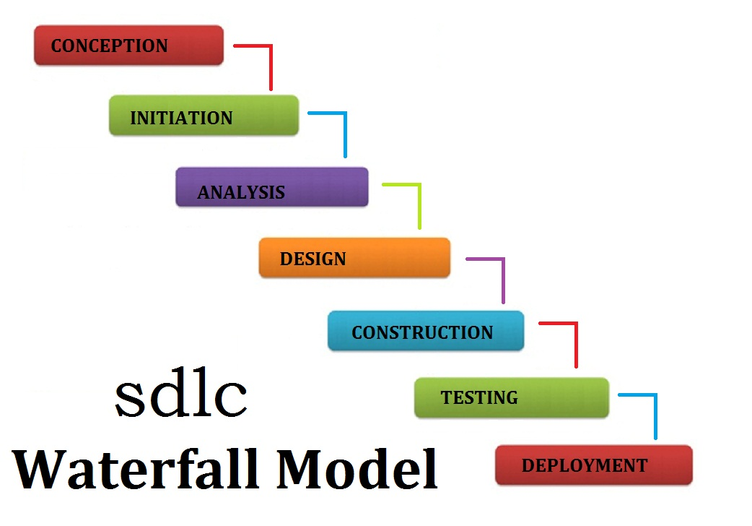

# System study

**Software And Hardware Requirements**

**The technical needs of a user that are required for implementation of the new system are as follows.**

## Hardware resources

**a) WINDOWS SERVER 2000(STANDARD CONFIGURATION)**

**PENTIUM IV BASED CPU**

**512 MB RAM**

**40GB HARD DISK ➢ 15’’ COLOR MONITOR**

**SCROLL MOUSE ➢ 104 KEY BOARD**

**VRAM WITH SVGA CARD**

**PRINTER**

## SOFTWARE RESOURCES

**OPERATING SYSTEM WINDOWS**

**DUMMY SERVER XAMPS SERVER**

**FRONT END PHP**

**LANGUAGE CSS, JAVASCRIPT, HTML**

**BACK END MY SQL**

**Web programming, also known as web development, is the creation of dynamic web applications. Examples of web applications are social networking sites like Facebook or e-commerce sites like Amazon. The good news is that learning web development is not that hard. In fact, many argue it’s the** [**best form of coding**](https://www.codeconquest.com/what-is-coding/where-to-start/) **for beginners to learn. It’s easy to set up, you get instant results and there’s plenty of online training available. A lot of people learn web coding because they want to create the next Facebook or find a job in the industry. But it’s also a good choice if you just want a general introduction to coding, since it’s super easy to get started. No matter whether you’re looking for a career or just want to learn coding, learning how to develop for the web is for you. It’s one of the smartest decisions you will ever make!There are two broad divisions of web development – front-end development (also called client-side development) and back-end development (also called server-side development).Front-end development refers to constructing what a user sees when they load a web application – the content, design and how you interact with it. This is done with three codes – HTML, CSS and JavaScript.HTML, short for** [**Hyper Text Mark-up Language,**](https://www.codeconquest.com/tutorials/html/) **is a special code for ‘marking up’ text in order to turn it into a web page. Every web page on the net is written in HTML, and it will form the backbone of any web application. CSS, short for** [**Cascading Style Sheets,**](https://www.codeconquest.com/tutorials/css/) **is a code for setting style rules for the appearance of web pages. CSS handles the cosmetic side of the web. Finally,** [**JavaScript**](https://www.codeconquest.com/tutorials/javascript/) **is a scripting language that’s widely used to add functionality and interactivity to web pages.Back-end development controls what goes on behind the scenes of a web application. A backend often uses a database to generate the front-end.Back-end scripts are written in many different coding languages and frameworks, such as** [**PHP**](https://www.codeconquest.com/tutorials/php/)

# SYSTEM DESIGN

## Entity relationship diagram

**An entity relationship[ diagram (ERD) shows the relationships of entity sets stored in a database . An entity in this context is a component of data. In other words, ER diagram illustrate the logical structured of databases.**

**At first glace an entity relationship diagram looks very much like a flowchart . it is the specialised symbols , and the meaning of those symbols that make it unique.**

**Peter Chen developed ERDs in 1976 . Since then Charles Bachman and James Martin have added some slight refinement to the basic ERD principles.**

## Common entire relationship diagram symbol

**An ER diagram is a means of visualising how the information a system lproduces is related. There are five main components of an ERD:**

**• Entities, which are represented by rectangle .An entity is an object or concept about which you want to store information.**

## ENTITY

**• Actions, which are represented by diamonds shape, show how two entities share information in the database**

**relationship**

**Weak Entities**

**A weak entity is a type of entity which doesn't have its key attribute. It can be identified uniquely by considering the primary key of another entity. For that, weak entity sets need to have participation.**

**Attributes**

**It is a single-valued property of either an entity-type or a relationship-type.**

**For example, a lecture might have attributes: time, date, duration, place, etc.**

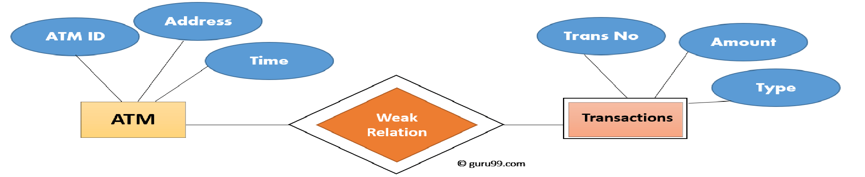**An attribute is represented by an Ellipse**

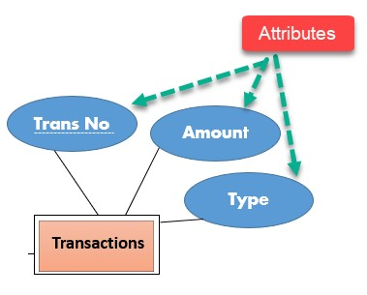

**ER- Diagram Notations**

**ER- Diagram is a visual representation of data that describe how data is related to each other.**

* **Rectangles: This symbol represent entity types.**
* **Ellipses : Symbol represent attributes**
* **Diamonds: This symbol represents relationship types**
* **Lines: It links attributes to entity types and entity types with other relationship types**
* **Primary key: attributes are underlined**
* **Double Ellipses: Represent multi-valued attributes**

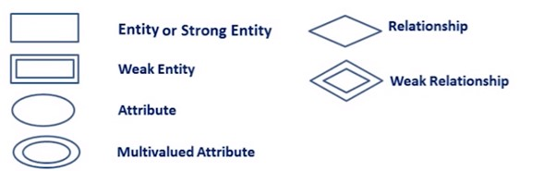

### Data flow diagram

**A data-flow diagram (DFD) is a way of representing a flow of a data of a** [**process**](https://en.wikipedia.org/wiki/Process) **or a system (usually an** [**information system)**](https://en.wikipedia.org/wiki/Information_system)**. The DFD also provides information about the outputs and inputs of each entity and the process itself. A data-flow diagram has no control flow; there are no decision rules and no loops. Specific operations based on the data can be represented by a** [**flowchart.**](https://en.wikipedia.org/wiki/Flowchart) **There are several notations for displaying data-flow diagrams. The notation presented above was described in 1979 by** [**Tom demarco**](https://en.wikipedia.org/wiki/Tom_DeMarco) **as part of Structured Analysis. The data-flow diagram is part of the structured-analysis modelling tools. When using UML, the** [**activity diagram**](https://en.wikipedia.org/wiki/Activity_diagram) **typically takes over the role of the data-flow diagram. A special form of data-flow plan is a site-oriented data-flow plan. Data-flow diagrams can be regarded as inverted** [**Petri nets,**](https://en.wikipedia.org/wiki/Petri_nets) **because places in such networks correspond to the semantics of data memories. Analogously, the semantics of transitions from Petri nets and data flows and functions from data-flow diagrams should be considered equivalent.**

**DFD components are:-**

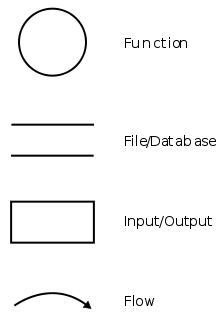

**DFD consists of processes, flows, warehouses, and terminators. There are several ways to view these DFD components.**

#### Process

**The process (function, transformation) is part of a system that transforms inputs to outputs. The symbol of a process is a circle, an oval, a rectangle or a rectangle with rounded corners (according to the type of notation). The process is named in one word, a short sentence, or a phrase that is clearly to express its essence.**

#### Data Flow

**Data flow (flow, dataflow) shows the transfer of information (sometimes also material) from one part of the system to another. The symbol of the flow is the arrow. The flow should have a name that determines what information (or what material) is being moved. Exceptions are flows where it is clear what information is transferred through the entities that are linked to these flows. Material shifts are modelled in systems that are not merely informative. Flow should only transmit one type of information (material). The arrow shows the flow direction (it can also be bi-directional if the information to/from the entity is logically dependent - e.g.**

**Question and answer). Flows link processes, warehouses and terminators.**

#### Warehouse

**The warehouse (data store, data store, file and database) is used to store data for later use. The symbol of the store is two horizontal lines; the other way of view is shown in the DFD Notation. The name of the warehouse is a plural noun (e.g. Orders) - it derives from the input and output streams of the warehouse. The warehouse does not have to be just a data file, for example, a folder with documents, a filing cabinet, and optical discs. Therefore, viewing the warehouse in DFD is independent of implementation. The flow from the warehouse usually represents the reading of the data stored in the warehouse, and the flow to the warehouse usually expresses data entry or updating (sometimes also deleting data). Warehouse is represented by two parallel lines between which the memory name is located (it can be modelled as a UML buffer node).**

#### Terminator

**The Terminator is an external entity that communicates with the system and stands outside of the system. It can be, for example, various organizations (eg a bank), groups of people (e.g. Customers), authorities (e.g. A tax office) or a department (e.g. A human-resources department) of the same organization, which does not belong to the model system. The terminator may be another system with which the modelled system communicates.**

**Rules for creating DFD**

**Entity names should be comprehensible without further comments. DFD is a system created by analysts based on interviews with system users. It is determined for system developers, on one hand, project contractor on the other, so the entity names should be adapted for model domain or amateur users or professionals. Entity names should be general (independent, e.g. Specific individuals carrying out the activity), but should clearly specify the entity. Processes should be numbered for easier mapping and referral to specific processes. The numbering is random, however, it is necessary to maintain consistency across all DFD levels (see DFD Hierarchy). DFD should be clear, as the maximum number of processes in one DFD is recommended to be from 6 to 9, minimum is 3 processes in one DFD. The exception is the so-called contextual diagram where the only process symbolizes the model system and all terminators with which the system communicates.**

**DFD consistency**

**DFD must be consistent with other models of the system - ERD, STD, Data Dictionary, and Process Specification models. Each process must have its name, inputs and outputs. Each flow should have its name (exception see Flow). Each Data store must have input and output flow. Input and output flows do not have to be displayed in one DFD - but they must exist in another DFD describing the same system. An exception is warehouse standing outside the system (external storage) with which the system communicates**

**DFD hierarchy**

**To make the DFD more transparent (i.e. Not too many processes), multi-level dfds can be created. Dfds that are at a higher level are less detailed (aggregate more detailed DFD at lower levels). The contextual DFD is the highest in the hierarchy (see DFD Creation Rules).**

**The so-called zero level is followed by DFD 0, starting with process numbering (e.g., process 1, process 2). In the next, the so-called first level - DFD 1 - the numbering continues. E.g.**

**Process 1 is divided into the first three levels of the DFD, which are numbered 1.1, 1.2 and**

**1.3. Similarly, processes in the second level (DFD 2) are numbered eg 1.1.1, 1.1.2, 1.1.3 and 1.1.4. The number of levels depends on the size of the model system. DFD 0 processes may not have the same number of decomposition levels. DFD 0 contains the most important (aggregated) system functions. The lowest level should include processes that make it possible to create a process specification (Process Specification) for roughly one A4 page. If the mini-specification should be longer, it is appropriate to create an additional level for the process where it will be decomposed into multiple processes. For a clear overview of the entire DFD hierarchy, a vertical (cross-sectional) diagram can be created. The warehouse is displayed at the highest level where it is first used and at every lower level as well.**

# OUTPUT

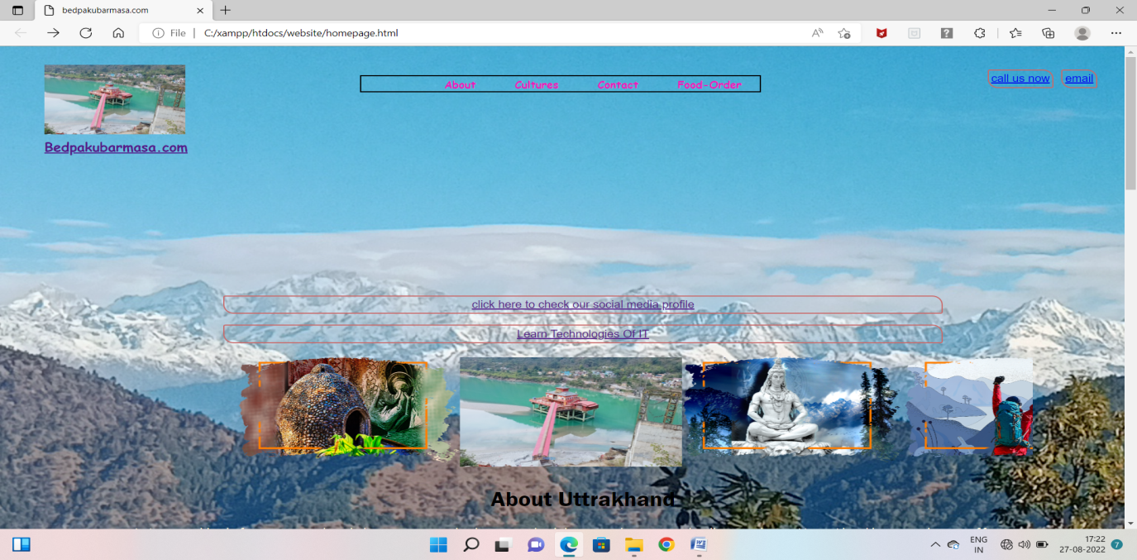

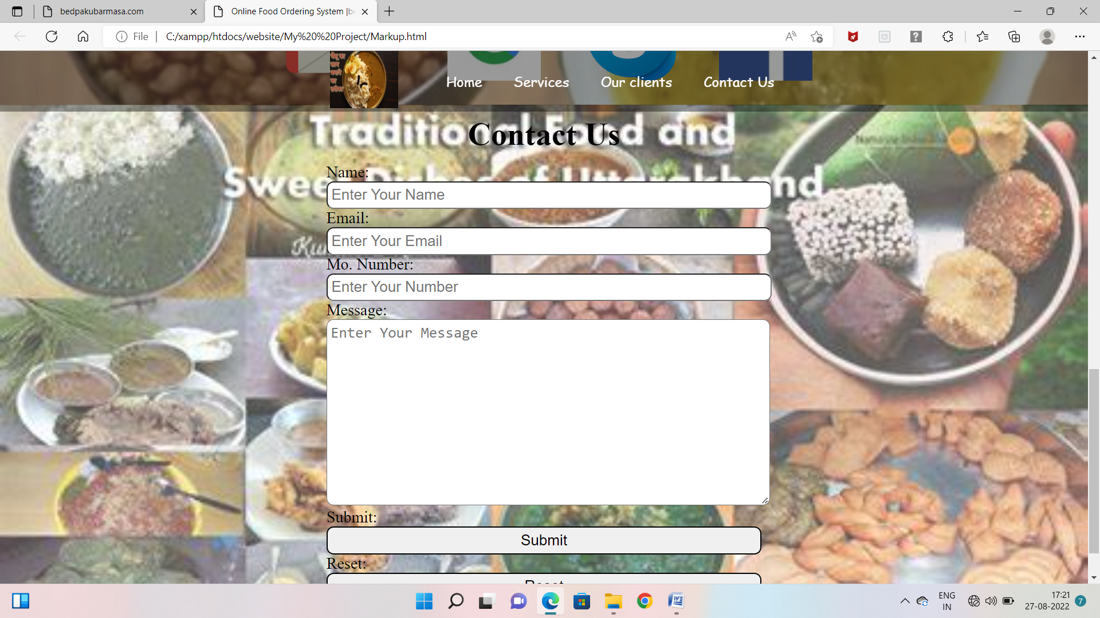

# Screenshot (53).png

# Screenshot (52).png

# Screenshot (50).pngScreenshot (51).png

# Screenshot (56).pngScreenshot (57).png

# Testing

## Testing

**Testing is the process of detecting errors. Testing performs a very critical role for quality assurance and for ensuring the reliability of the software. The results of testing are used later on during maintenance also.Testing means the process of analyzing the software item to detect the differences between existing or required condition and evaluate the features of the software items. The thorough testing of the system before release of the software needs to be done vide the various test cases and modes so that the software becomes devoid of bugs and uses minimum space requirements as well as minimum time to perform. The test cases were selected before hand with expected results defined and actual results recorded for comparison. The selection of test cases is done vide “White Box Testing” technique to check the internal programming logic and efficiency and vide ”Black Box Testing” technique to check software requirement fulfillment with intension of finding maximum number of errors with minimum effort and time. Although test cases are a design by considering the cyclomatic complexity, conditional test, still the software code is not in its optional form, as all other possible alternative parts in the software are not considered. At the integration level, the software will be passing to the third party tests which would further enhance the software optimality and efficiency.**

**Test Characters:**

1. **A good test has a high probability of finding an error.**
2. **A good test is not redundant.**
3. **A good test should be “best of breed”.**
4. **A good test should be neither too simple nor too complex.**

**Black Box Testing:**

**The method of Black Box testing is used by the software engineer to derive the required results of the test cases:**

1. **Black Box Testing alludes to test that are conducted at the software interface.**
2. **A Black Box Test examines some fundamental aspect of a system with little regard for the internal logic structure of the software.**
3. **A limited number of important logical paths can be selected and exercised.**
4. **Important data structure can be probed for validity.**

**White Box Testing:**

**White Box Testing is sometimes called Glass Box Testing. Using White Box Testing methods the software engineer can derive the following test cases:**

1. **Guarantee that all independent paths within a module have been exercised at least once.**
2. **Exercise all logical decisions on their true and false sides.**
3. **Execute all loops at their boundaries and within their operational bounds.**
4. **Exercise internal data structures to ensure the validity.**

**Test Plan:**

**Testing means the process of analyzing a software item to detect the difference between the existing and required permission and to evaluate the features of the software item. Once the test plan is ready and the test cases are completely designed, different level of testing starts.**

**Unit Testing:**

**The unit testing is performed to test the validity of the individuals units. This is done in the coding phase with the interactive testing. Unit testing phase (sometimes called the implementation phase) of software development is to translate the software design into source code. Each component of the design is implemented as a program module. The end-product of this phase is a set of program modules that have been individually tested. During this phase, each module is unit tested to determine the correct working of all the individual modules. It involves testing each module in isolation as this is the most efficient way to debug the errors identified at this stage. We used the unit testing plans prepared in the design phase of the system development as guide. The testing was carried out during the coding itself. Each module of this project was found to be working according to the expected output from the module.**

**Integrity Testing:**

**When all the development of all the units or modules is completed and integrated the integrity test phase is started. In this phase the modules are integrated in a planned manner. The different modules making up a software product are almost never integrated in one shot. Integration is normally carried out incrementally over a number of steps. During each integration step, the partially integrated system is tested and a set of previously planned modules are added to it. Finally, when all the modules have been successfully integrated and tested, system testing is carried out. This testing is done with simple data and the development system has run successfully this simple data. The need for integrated system is to find the overall system performance.**

**System Testing:**

**The system testing phase incorporates the performance stress testing so as to meet the product criteria with respect to the desired bench marks. This is necessary test for highly data intensive product.**

**System testing usually consists of three different kinds of testing activities:**

* **α – Testing: It is the system testing performed by the development team.**
* **β – Testing: It is the system testing performed by a friendly set of customers.**
* **Acceptance Testing: It is the system testing performed by the customer himself after the product delivery to determine whether to accept or reject the delivered product. System testing is normally carried out in a planned manner according to the system test plan document. The system test plan identifies all testing related activities that must be performed, specifies the schedule of testing, and allocates resources. It also lists all the test cases and the expected outputs for each test case.**

**Here the System testing involved is the most widely used testing process consisting of five stages as shown in the figure. In general, the sequence of testing activities is component testing, integration testing, and then user testing. However, as defects are discovered at any one stage, they require program modifications to correct them and this may require other stages in the testing process to be repeated.**

# 

# Maintenance

**Maintenance**

**A common perception of maintenance is that it merely involves fixing****defects**[**.**](https://en.wikipedia.org/wiki/Software_bug) **However, one study indicated that over 80% of maintenance effort is used for noncorrective actions. This perception is perpetuated by users submitting problem reports that in reality are functionality enhancements to the system. More recent studies put the bug-fixing proportion closer to 21%.**

**In the late 1970s, a famous and widely cited survey study by Lientz and Swanson, exposed the very high fraction of****life-cycle costs****that were being expended on maintenance. They categorized maintenance activities into four classes:**

* **Adaptive – modifying the system to cope with changes in the software environment** [**(DBMS,**](https://en.wikipedia.org/wiki/DBMS) [**OS)**](https://en.wikipedia.org/wiki/Operating_system)
* **Perfective – implementing new or changed user requirements which concern functional enhancements to the software**
* **Corrective – diagnosing and fixing errors, possibly ones found by users** [**]**](https://en.wikipedia.org/wiki/Software_maintenance#cite_note-csse.monash.edu.au-4)
* **Preventive – increasing software maintainability or reliability to prevent problems in the future**

**Software maintenance processes**

**This section describes the six software maintenance processes as:**

* 1. **The implementation process contains software preparation and transition activities, such as the conception and creation of the maintenance plan; the preparation for handling problems identified during development; and the follow-up on product configuration management.**
  2. **The problem and modification analysis process, which is executed once the application has become the responsibility of the maintenance group. The maintenance programme must analyze each request, confirm it (by reproducing the situation) and check its validity, investigate it and propose a solution, document the request and the solution proposal, and finally, obtain all the required authorizations to apply the modifications.**
  3. **The process considering the implementation of the modification itself.**
  4. **The process acceptance of the modification, by confirming the modified work with the individual who submitted the request in order to make sure the modification provided a solution.**
  5. **The migration process (**[**platform migration,**](https://en.wikipedia.org/wiki/Software_migration) **for example) is exceptional, and is not part of daily maintenance tasks. If the software must be ported to another platform without any change in functionality, this process will be used and a maintenance project team is likely to be assigned to this task.**
  6. **Finally, the last maintenance process, also an event which does not occur on a daily basis, is the retirement of a piece of software.**

**Maintenance Factors**

|  |  |
| --- | --- |
| **Maintenance Factors** | **Plus Range** |
| **Maintenance specialists** | **35%** |
| **High staff experience** | **34%** |
| **Table-driven variables and data** | **33%** |
| **Low complexity of base code** | **32%** |
| **Y2K and special search engines** | **30%** |
| **Code restructuring tools** | **29%** |
| **Re-engineering tools** | **27%** |

**High level programming languages 25%**

|  |  |
| --- | --- |
| **Reverse engineering tools** | **23%** |
| **Complexity analysis tools** | **20%** |
| **Defect tracking tools** | **20%** |
| **Y2K “mass update” specialists** | **20%** |
| **Automated change control tools** | **18%** |
| **Unpaid overtime** | **18%** |
| **Quality measurements** | **16%** |
| **Formal base code inspections** | **15%** |
| **Regression test libraries** | **15%** |
| **Excellent response time** | **12%** |
| **Annual training of > 10 days** | **12%** |
| **High management experience** | **12%** |
| **HELP desk automation** | **12%** |
| **No error prone modules** | **10%** |
| **On-line defect reporting** | **10%** | |
| **Productivity measurements** | **8%** | |
| **Excellent ease of use** | **7%** | |
| **User satisfaction measurements** | **5%** | |
| **High team morale** | **5%** | |
| **Sum** | **503%** | |

* 1. **Not only are error-prone modules troublesome, but many other factors can degrade performance too. For example, very complex** [**spaghetti code**](https://en.wikipedia.org/wiki/Spaghetti_code) **is quite difficult to maintain safely. A very common situation which often degrades performance is lack of suitable maintenance tools, such as defect tracking software, change management software, and test library software. Below describe some of the factors and the range of impact on software maintenance.**
  2. **Impact of key adjustment factors on maintenance (sorted in order of maximum negative impact)**

|  |  |
| --- | --- |
| **Maintenance Factors** | **Minus Range** |
| **Error prone modules** | **-50%** |
| **Embedded variables and data** | **-45%** |
| **Staff inexperience** | **-40%** |
| **High code complexity** | **-30%** |
| **No Y2K of special search engines** | **-28%** |
| **Manual change control methods** | **-27%** |
| **Low level programming languages** | **-25%** |
| **No defect tracking tools** | **-24%** |
| **No Y2K “mass update” specialists** | **-22%** |
| **Poor ease of use** | **-18%** |
| **No quality measurements** | **-18%** |
| **No maintenance specialists** | **-18%** |
| **Poor response time** | **-16%** |
| **No code inspections** | **-15%** |
| **No regression test libraries** | **-15%** |
| **No help desk automation** | **-15%** |
| **No on-line defect reporting** | **-12%** |
| **Management inexperience** | **-15%** |
| **No code restructuring tools** | **-10%** |
| **No annual training** | **-10%** |
| **No reengineering tools** | **-10%** |
| **No reverse-engineering tools** | **-10%** |
| **No complexity analysis tools** | **-10%** |
| **No productivity measurements** | **-7%** |
| **Poor team morale** | **-6%** |

**No user satisfaction measurements -4%**

**No unpaid overtime 0%**

**Sum -500%**

# 

**FUTURE SCOPE**

## Future scope

**As system grew more complex, it become evident that the goal of the entire system cannot be easily comprehended. Hence need for the requirement analysis phase arose. Now, for large software system, requirement analysis is perhaps the most difficult activity and also the most error prone.**

**Some of the difficulty is due to the scope of this phase. The software project is imitated by the client needs. in the beginning these needs are in the minds of various people in the client organisation. The requirements analyst has to identify the requirement by tracking to these people and understanding their needs. in situation where the software is to automated a currently manuals process, most of the needs can be understood by observing the current practice.**

# Conclusion

**Conclusion**

**It is concluded that the application works well and satisfy the company and user. The application is tested well and errors are properly debugged. The site is simultaneously accessed from more than one system. Simultaneously login from more than one place is tested.**

**This site works according to the restriction provided in their respective browser. Further enhancement can be made to the application, so that the web site functions very interactive and useful to existing application. The application satisfies both the company and user by eliminating more input. The speed of the transactions become more enough now.**

# References

**BIBILIOGRAPHY**

## Websites referred:-

* [**https://www.w3schools.com**](https://www.w3schools.com/)
* [**https://www.tutorialspoint.com**](https://www.tutorialspoint.com/)
* [**https://www.stackoverflow.com**](https://www.stackoverflow.com/)
* [**https://www.codeacademy.com**](https://www.codeacademy.com/)